**Hancock County K-9 off duty after biting his deputy handler**

**April 8, 2016**

By STEPHEN HUBA - Staff writer ([shuba@reviewonline.com](mailto:shuba@reviewonline.com)) , Weirton Daily Times

[Save](http://www.weirtondailytimes.com/?page=mscontent.saveContentMsg&showlayout=0&id=662401&nav=5006) | [Post a comment](http://www.weirtondailytimes.com/page/content.comment/id/662401/Hancock-County-K-9-off-duty-after-biting-his-deputy-handler.html?nav=5006) |

NEW CUMBERLAND - The Hancock County Sheriff's Department has taken one of its police dogs out of service after he bit and seriously injured his handler.

The dog, a black Belgian Malinois named Nitro, was acquired by the department in December 2014 and assigned to Deputy 1st Class Scott Little as a replacement for his German shepherd, Christina.

Nitro bit Little in the forearm during a locker training exercise at Oak Glen Middle School earlier this year, requiring Little to get 20 stitches and take two weeks off of work, Sheriff Ralph Fletcher said. No students were present at the time of the attack, which was captured on video, he said.

Article Photos

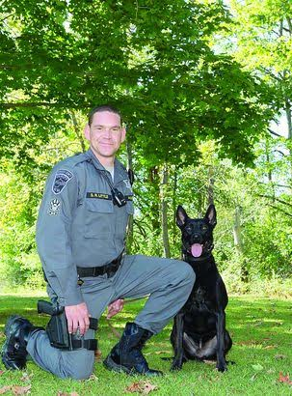

NITRO’S WOES — Hancock County sheriff’s Deputy 1st Class Scott Little poses with his K-9 Nitro for a picture posted on the K-9 Unit’s Facebook page in November 2015. Nitro, a 2-year-old Belgian Malinois, recently was released from duty after an attack on Little. – Contributed

Fletcher took the dog out of commission immediately. "I don't feel he's safe for the citizens of Hancock County," he said. "He may be suitable for another environment."

On Thursday, Hancock County commissioners approved an ownership transfer whereby Nitro will become the property of Mark Darcangelo of the Grey Dog Group, a shelter for retired military and police dogs in West Harrison, Ind.

The sheriff's department acquired the dog for $5,000 and handled most of its training in-house.

But Fletcher said the dog had become unreliable, unpredictable and unresponsive to commands.

"He wouldn't 'out' on command, which means he had to be physically removed when he latched onto something," Fletcher said. "You couldn't get him to decide to let go."

Fletcher also described the dog as "stubborn" and as one who would bite without being provoked.

"We don't know if it was something inherent to this particular dog or whether it was something in his training or temperament," he said. "It doesn't happen every day, but it does happen."

The dog's removal means that the sheriff's department, budgeted for four K-9s, is down to two dogs - a German shepherd named Odin, whose handler is Sgt. Eric Cline, and a Belgian Malinois/German shepherd mix named Midas, whose handler is Deputy 1st Class Pat Hoder.

Fletcher said the department will have to raise money for a replacement for Nitro. It still has not found a replacement for Lt. Chuck Stanley and his German shepherd, Jesy.

Much of the department's K-9 fund was depleted by the purchase of Nitro and Midas. The department's K-9 budget covers care and housing costs but not the acquisition of dogs, he said.